The 14th ASOS (2023) ABSTRACT PREPARATION GUIDELINES
(CAPITAL CHARACTERS, TIMES NEW ROMAN, 14 POINTS)

Author Oneª, Author Two^{b}, Author Three^{b,*} , …(12-point, centered)

ªLERMA, Sorbonne Université and Paris Observatory, Meudon Campus, 92190 Meudon, France
^{b}LPCQ, University Mouloud Mammeri, BP17 RP, Tizi-Ouzou, 15000 Algeria
(12-point, centered)

The abstract has to be prepared in a camera-ready single spaced A4 paper format (210 x 297 mm), leaving a space of 20 mm at top and 25 mm at left, right and bottom edges. It should be strictly limited to one page, including all figures and references. The font used should be Times New Roman 12-point, except for the abstract title which should be in Times New Roman 14-point bold capital lettering. The lines should be single-spaced and justified.

The abstract must begin with the title followed by the names of the authors and the addresses of their institutions. The title, authors and addresses should be centered on the page. The name of the author responsible for presenting the poster should be bold. The corresponding author should be noted by an asterix. References in the text must be numbered and enclosed in square brackets, for example [1]. The list of references should be placed at the end of the abstract. There should be no page number.
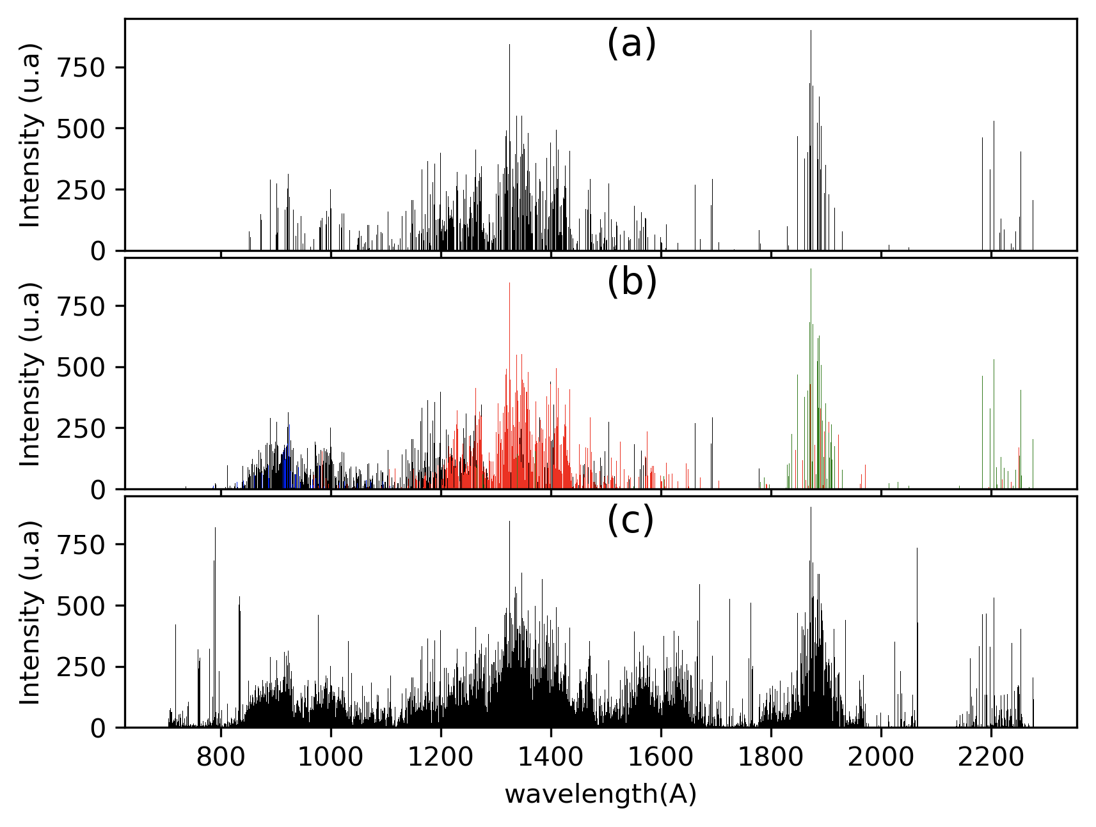
Figure 1: This is an example of figure. Please prepare the figures in high resolution (300 dpi).

Abstracts are to be submitted through the website of the conference. The format for abstract submission is Adobe’s Portable Document Format (.pdf). The file name should be the presenting author’s name, e.g. “FirstName_FamilyName.pdf”.

References
[1] A. One, A. Two, A. Three, et al, J. Phys. Conf. Ser. 58, 1 (2007)

*email: abc@abc.com

